Текстовый экран WH1602 и датчик температуры и влажности DHT11
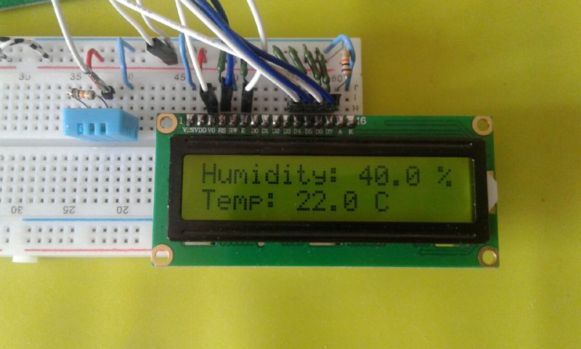
Пины GPIO orangepi
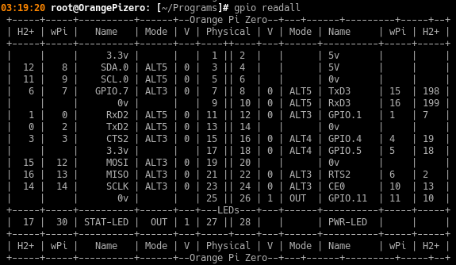
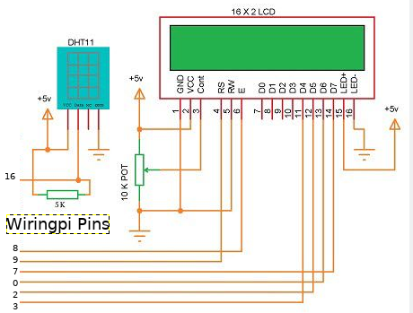
Схема подключения. Пины можно менять.

Библиотека lcd.h доступна из стандартных WiringPi
( https://pcminipro.ru/orangepi/wiringop-wiringpi-na-orange-pi/ )
/*
* lcd.h:
* Text-based LCD driver.
* This is designed to drive the parallel interface LCD drivers
* based in the Hitachi HD44780U controller and compatables.
*
* Copyright (c) 2012 Gordon Henderson.

#define MAX_LCDS 8

#ifdef __cplusplus
extern "C" {
#endif

extern void lcdHome (const int fd) ;
extern void lcdClear (const int fd) ;
extern void lcdDisplay (const int fd, int state) ;
extern void lcdCursor (const int fd, int state) ;
extern void lcdCursorBlink (const int fd, int state) ;
extern void lcdSendCommand (const int fd, unsigned char command) ;
extern void lcdPosition (const int fd, int x, int y) ;
extern void lcdCharDef (const int fd, int index, unsigned char data [8]) ;
extern void lcdPutchar (const int fd, unsigned char data) ;
extern void lcdPuts (const int fd, const char *string) ;
extern void lcdPrintf (const int fd, const char *message, ...) ;

extern int lcdInit (const int rows, const int cols, const int bits,
const int rs, const int strb,
const int d0, const int d1, const int d2, const int d3, const int d4,
const int d5, const int d6, const int d7) ;

#ifdef __cplusplus
}
#endif

DHT11
https://akizukidenshi.com/download/ds/aosong/DHT11.pdf - Datasheet
Step 1: After power on DHT11 (DHT11 on after power to wait 1S across the unstable state during this period can not send any instruction), the test environment temperature and humidity data, and record the data, while DHT11 the DATA data lines pulled by pull-up resistor has been to maintainhigh; the DHT11 the DATA pin is in input state, the moment of detection of external signals.
Step 2: Microprocessor I / O set to output at the same time output low, and low hold time can not be less than 18ms, then the microprocessor I / O is set to input state, due to the pull-up resistor, a microprocessor/ O DHT11 the dATA data lines also will be high, waiting DHT11 to answer signal, send the signal as shown.

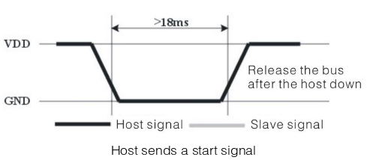
Step 3: DATA pin is detected to an external signal of DHT11 low, waiting for external signal low end the delay DHT11 DATA pin in the output state, the output low of 80 microseconds as the response signal, followed by the output of 80 micro-seconds of high notification peripheral is ready to receive data, the microprocessor I / O at this time in the input state is detected the I / O low (DHT11 response signal), wait 80 microseconds highdata receiving and sending signals as shown:
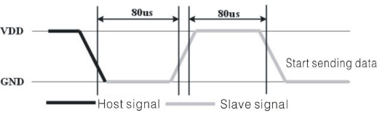
Step 4: Output by DHT11 the DATA pin 40, the microprocessor receives 40 data bits of data "0" format: the low level of 50 microseconds and 26-28 microseconds according to the changes in the I / O levellevel, bit data "1" format: the high level of low plus, 50 microseconds to 70 microseconds. Bit data "0", "1" signal format as shown:
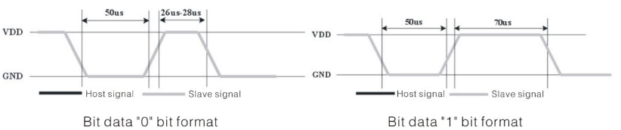
End signal: Continue to output the low 50 microseconds after DHT11 the DATA pin output 40 data, and changed the input state, along with pull-up resistor goes high. But DHT11 internal re-test environmental temperature and humidity data, and record the data, waiting for the arrival of the external signal.

Weather.c
#include <wiringPi.h>
#include <lcd.h>
#include <stdio.h>
#include <stdlib.h>
#include <stdint.h>

//USE WIRINGPI PIN NUMBERS
#define LCD_RS 25 //Register select pin
#define LCD_E 24 //Enable Pin
#define LCD_D4 23 //Data pin 4
#define LCD_D5 22 //Data pin 5
#define LCD_D6 21 //Data pin 6
#define LCD_D7 14 //Data pin 7
#define MAXTIMINGS 85
#define DHTPIN 7

int lcd;
int dht11_dat[5] = {0, 0, 0, 0, 0};

void read_dht11_dat(){
uint8_t laststate = HIGH;
uint8_t counter = 0;
uint8_t j = 0, i;
float f;

dht11_dat[0] = dht11_dat[1] = dht11_dat[2] = dht11_dat[3] = dht11_dat[4] = 0;
//step 2
pinMode(DHTPIN, OUTPUT);
digitalWrite(DHTPIN, LOW);
delay(18);
//step 3
digitalWrite(DHTPIN, HIGH);
delayMicroseconds(40);

pinMode(DHTPIN, INPUT);

for (i = 0; i < MAXTIMINGS; i++){
counter = 0;
while (digitalRead(DHTPIN) == laststate){
counter++;
delayMicroseconds(1);
if (counter == 255){
break;
}
}
laststate = digitalRead(DHTPIN);

if (counter == 255)
break;

if ((i >= 4) && (i % 2 == 0)){
dht11_dat[j / 8] <<= 1;
if (counter > 16)
dht11_dat[j / 8] |= 1;
j++;
}
}

if ((j >= 40) && (dht11_dat[4] == ((dht11_dat[0] + dht11_dat[1] + dht11_dat[2] + dht11_dat[3]) & 0xFF))){
f = dht11_dat[2] * 9. / 5. + 32;
lcdClear(lcd);
lcdPosition(lcd, 0, 0);
lcdPrintf(lcd, "Humidity: %d.%d %%\n", dht11_dat[0], dht11_dat[1]);

lcdPosition(lcd, 0, 1);
lcdPrintf(lcd, "Temp: %d.0 C", dht11_dat[2]);
}
}

int main(void){
int lcd;
wiringPiSetup();
lcd = lcdInit (2, 16, 4, LCD_RS, LCD_E, LCD_D4, LCD_D5, LCD_D6, LCD_D7, 0, 0, 0, 0);

while (1){
read_dht11_dat();
delay(1000);
}
return(0);
}

